Arselan Alvi

Maneek Dhillon

Wyatt Goodsite

Sridevi Kuchibotla

CMPE 131 Team 4: Design Document

UML Class Diagram:

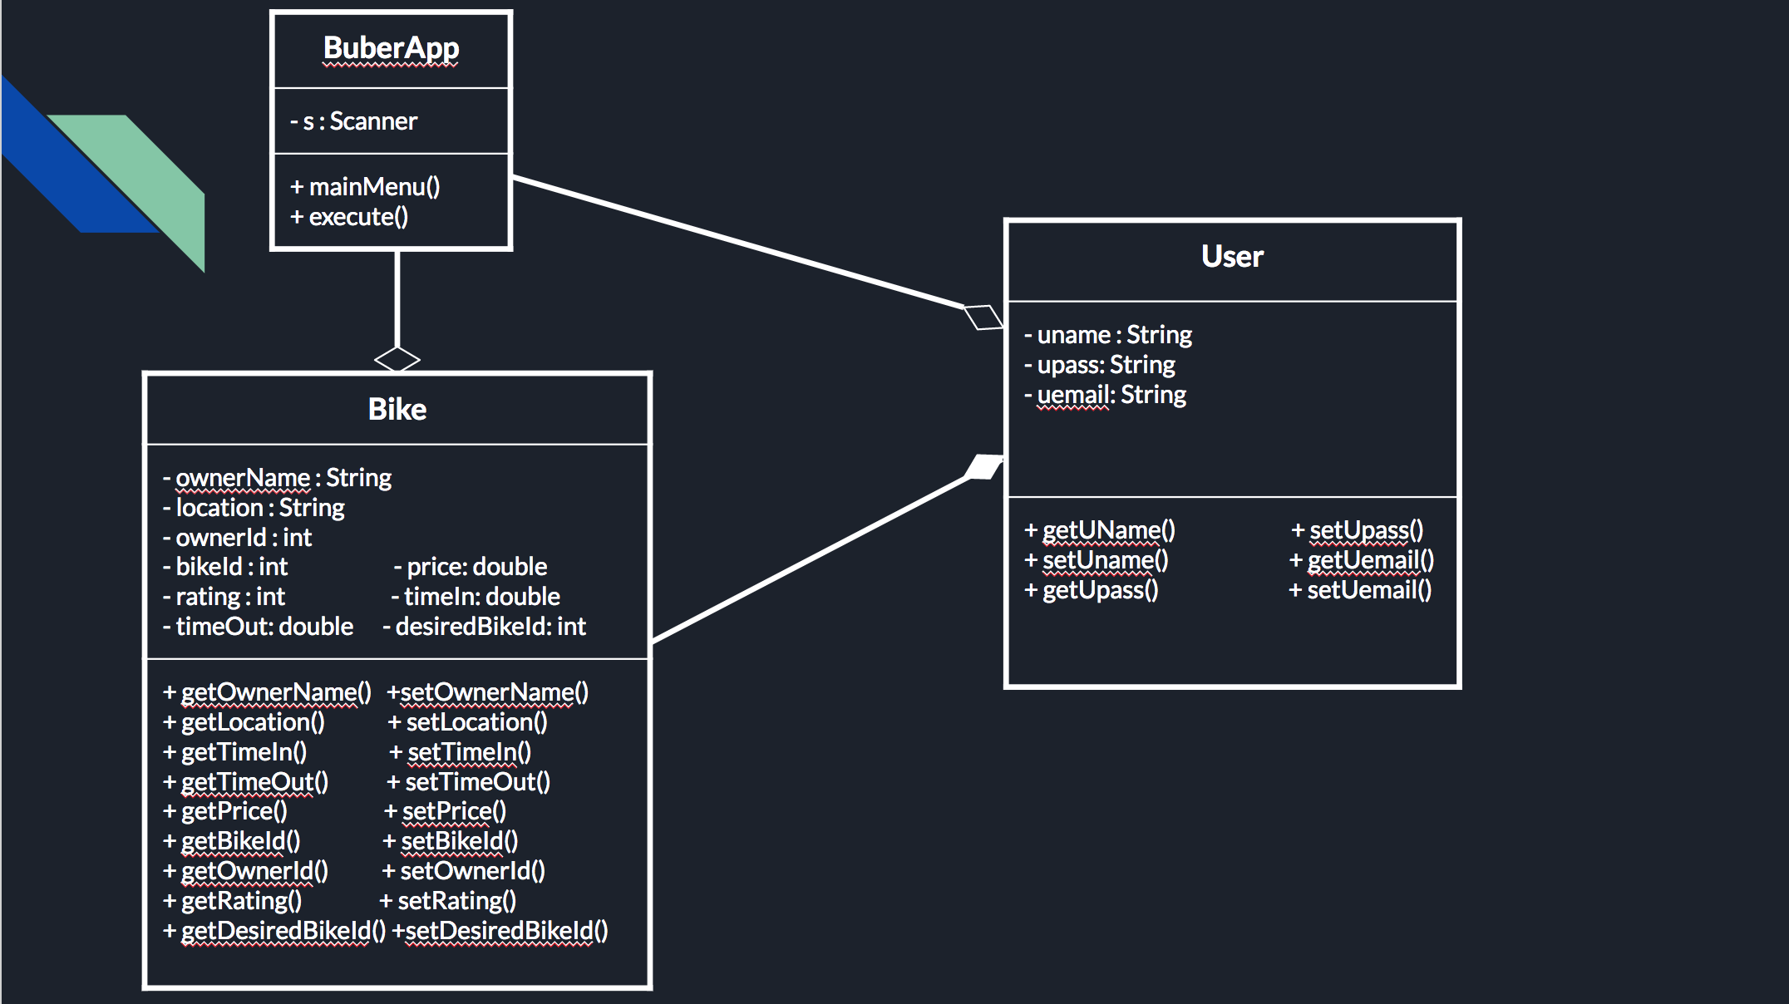

UML Sequence Diagram

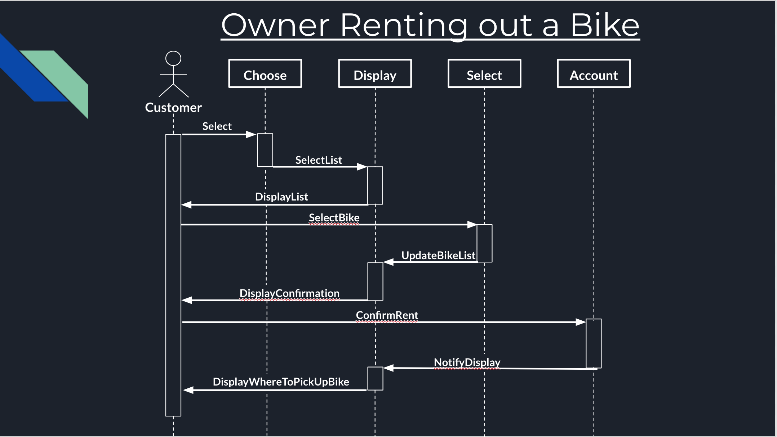

ER Diagram: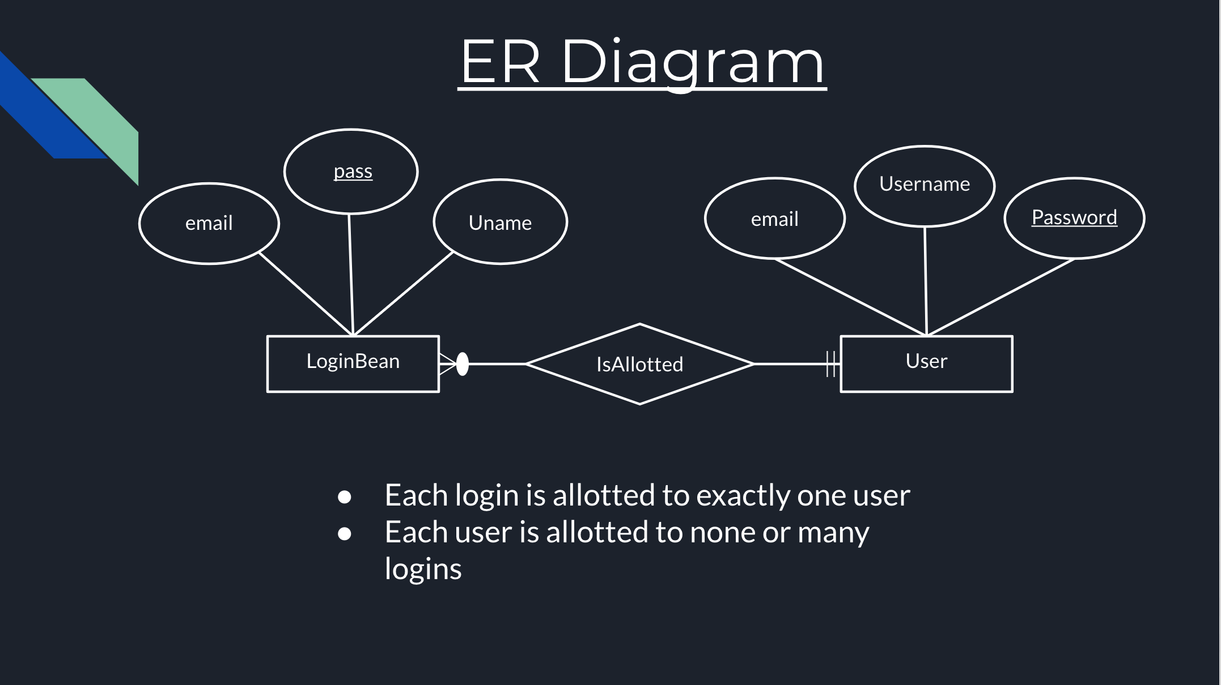

Relational Diagram: